Question 2

Table fields :

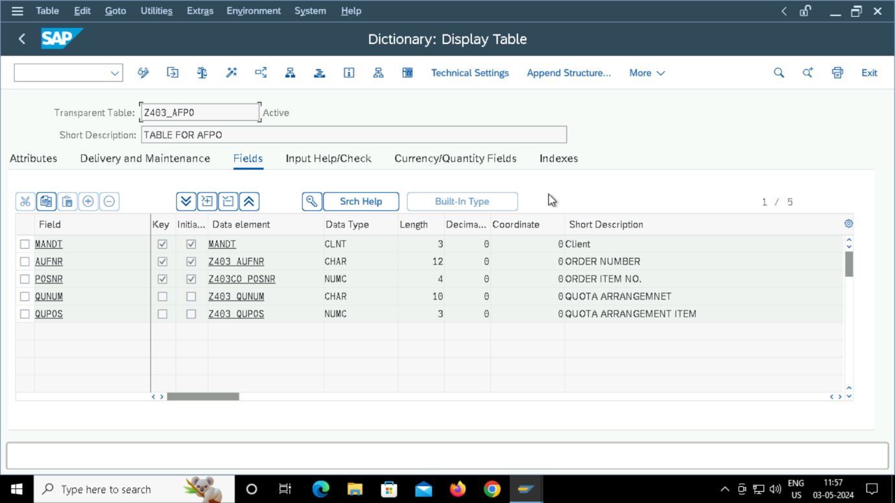

TMG :

